<INTRODUCTION TO DATA MANAGEMENT>
PROJECT REPORT
(Project Semester January-April 2025)

(HR ANALYTICS DASHBOARD)

Submitted by
(Kanithi Naresh Kumar)

Registration No 12313053
Roll number: 58

Section K23EV
Course Code INT217

Under the Guidance of

(Dr.Mrinalini Rana)

Discipline of CSE/IT

Lovely School of Computer Science & Engineering

Lovely Professional University, Phagwara

CERTIFICATE

This is to certify that Kanithi Naresh Kumar bearing Registration no.12313053 has completed .INT217 project titled, “Dashboard” under my guidance and supervision. To the best of my knowledge, the present work is the result of his/her original development, effort and study.

Signature and Name of the Supervisor
Designation of the Supervisor
School of Computer science & Engineering
Lovely Professional University
Phagwara, Punjab.

Date: 12 April 2025

DECLARATION

I, Kanithi Naresh Kumar, student of Computer science & engineering under CSE/IT Discipline at, Lovely Professional University, Punjab, hereby declare that all the information furnished in this project report is based on my own intensive work and is genuine.

Date: 12 April 2025 Signature
Registration No. 12313053 K.Naresh

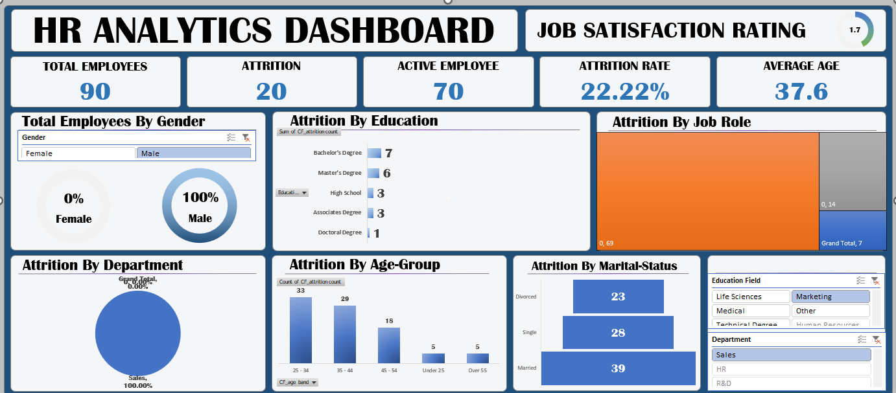
Objectives
- Average of Job Satisfaction.
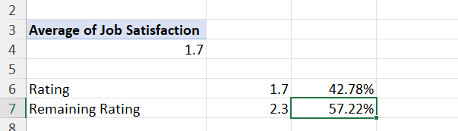
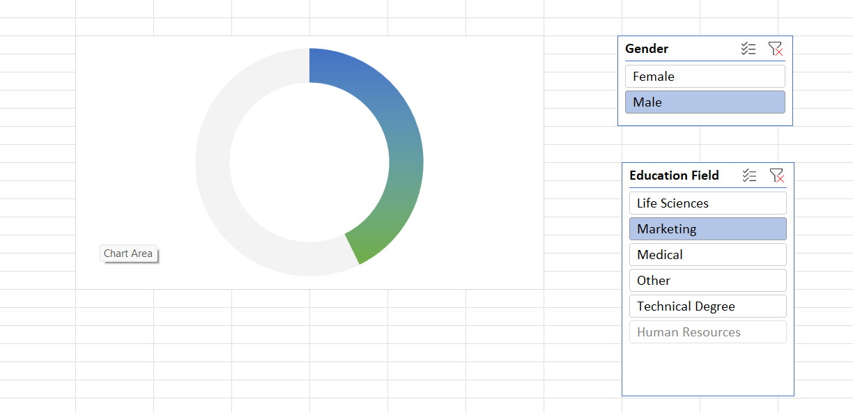

2 Count of Employee Numbers by Genders.
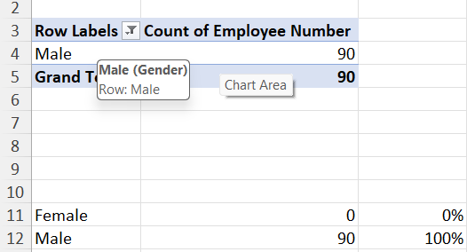
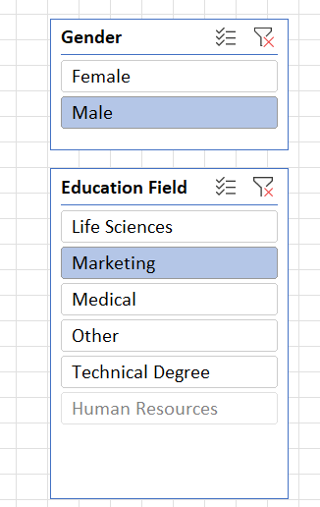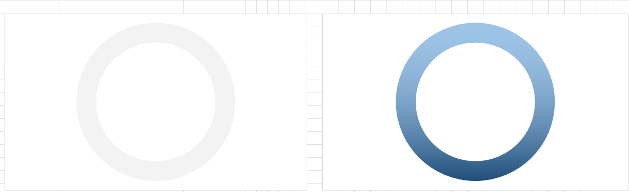
3)Attirition By Job Role.
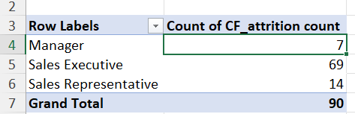
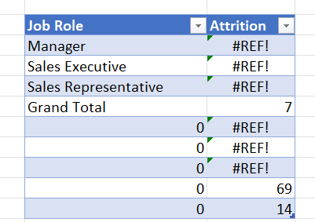
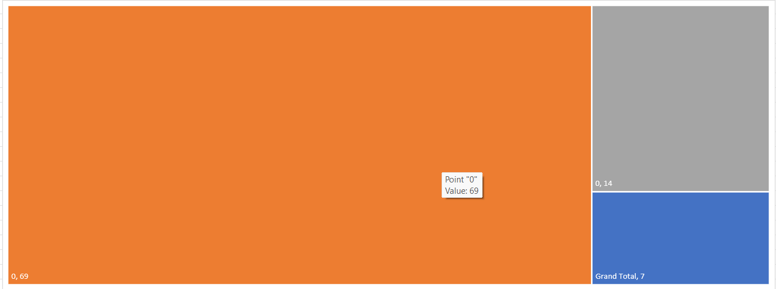

4) Attrition By Age Group.
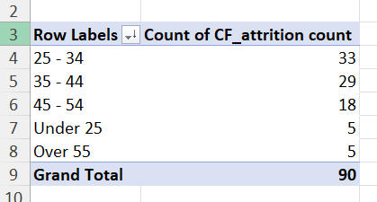
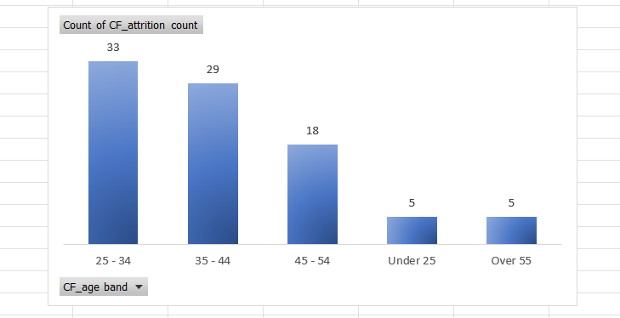

5) Attirition By Marriage Status.

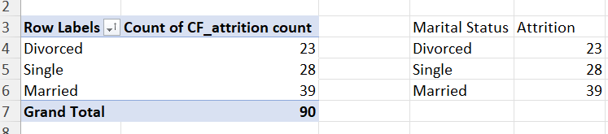

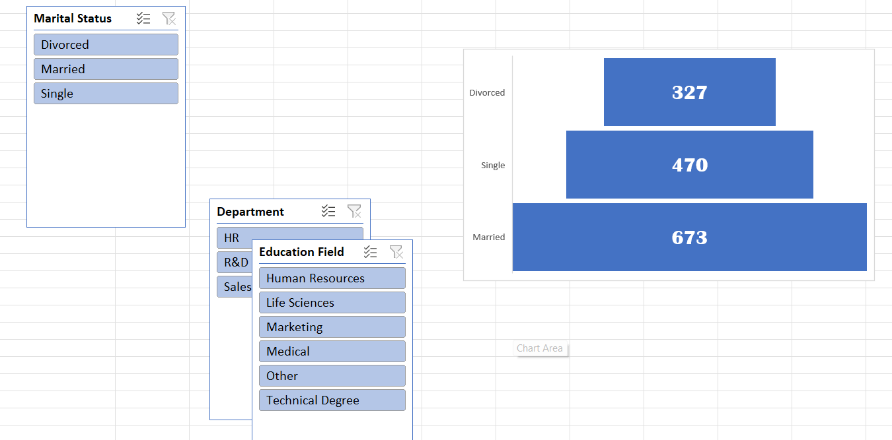

Linkedin Link: https://www.linkedin.com/posts/nareshkumarkanithi_lpudatasciencestudent-activity-7316756534783315968-tEbw?utm_source=social_share_send&utm_medium=android_app&rcm=ACoAAEgDm0wBYikTJtVwabTkFmNomL8M7lWhkuk&utm_campaign=whatsapp

